**Final Project Lab**

Paul Polsinelli

Information Technology, Arizona State University

IFT 472: Managing the Cloud

Professor Neff

Oct 9th, 2020

**Final Project Lab**

**Figure 1**

*A screenshot of the Security Group*

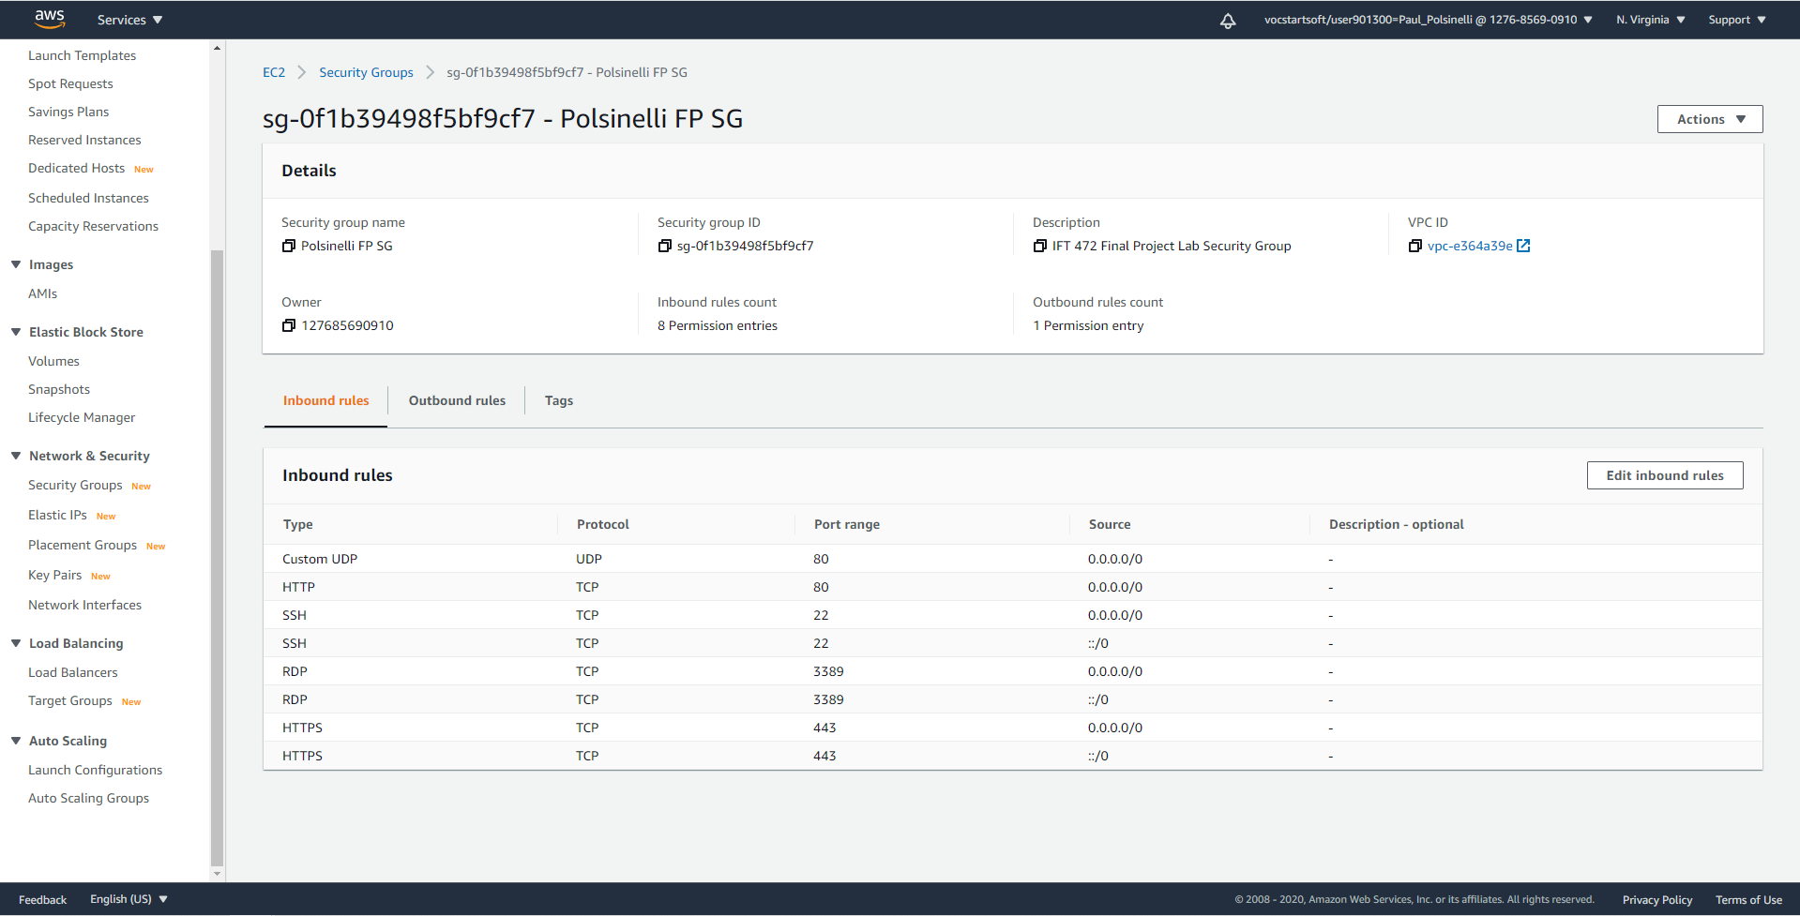

**Figure 2**

*A screenshot of PolsinelliFP1 running with Polsinelli FP SG*

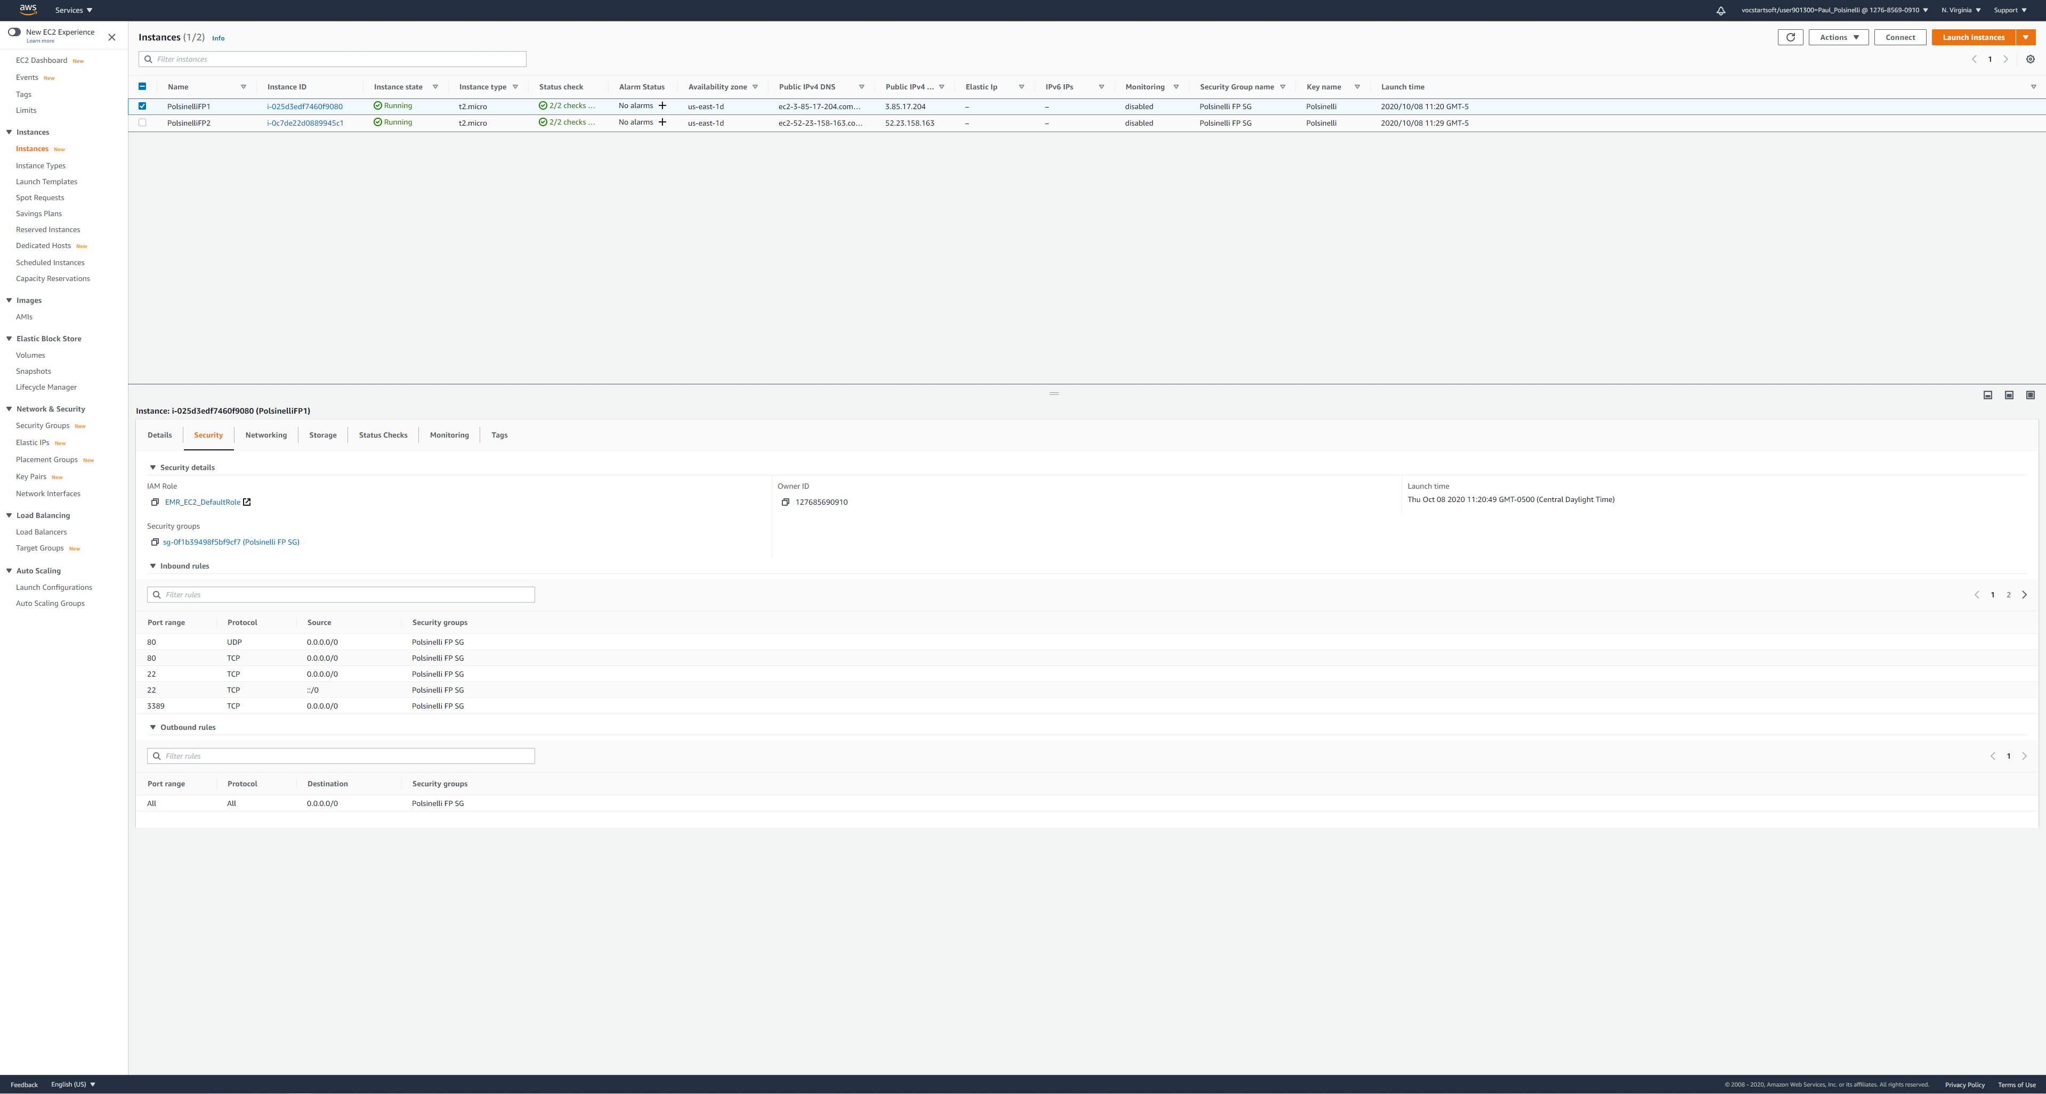

**Figure 3**

*A screenshot of PolsinelliFP2 running with Polsinelli FP SG*

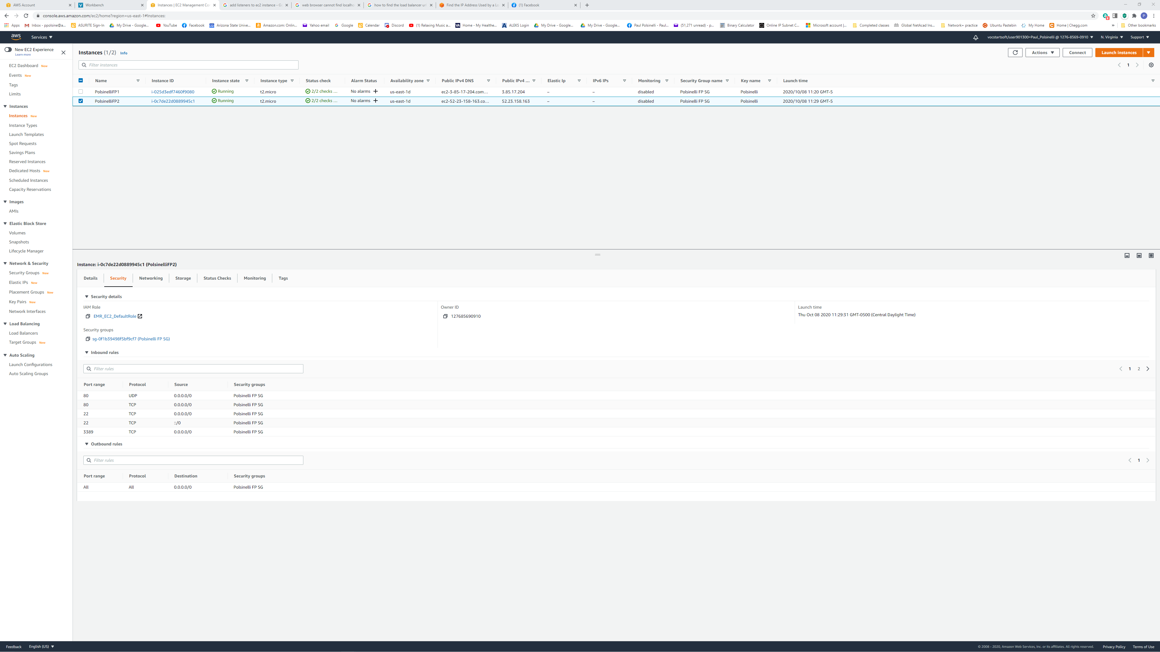

**Figure 4**

*A screenshot of PolsinelliFP1 and localhost*

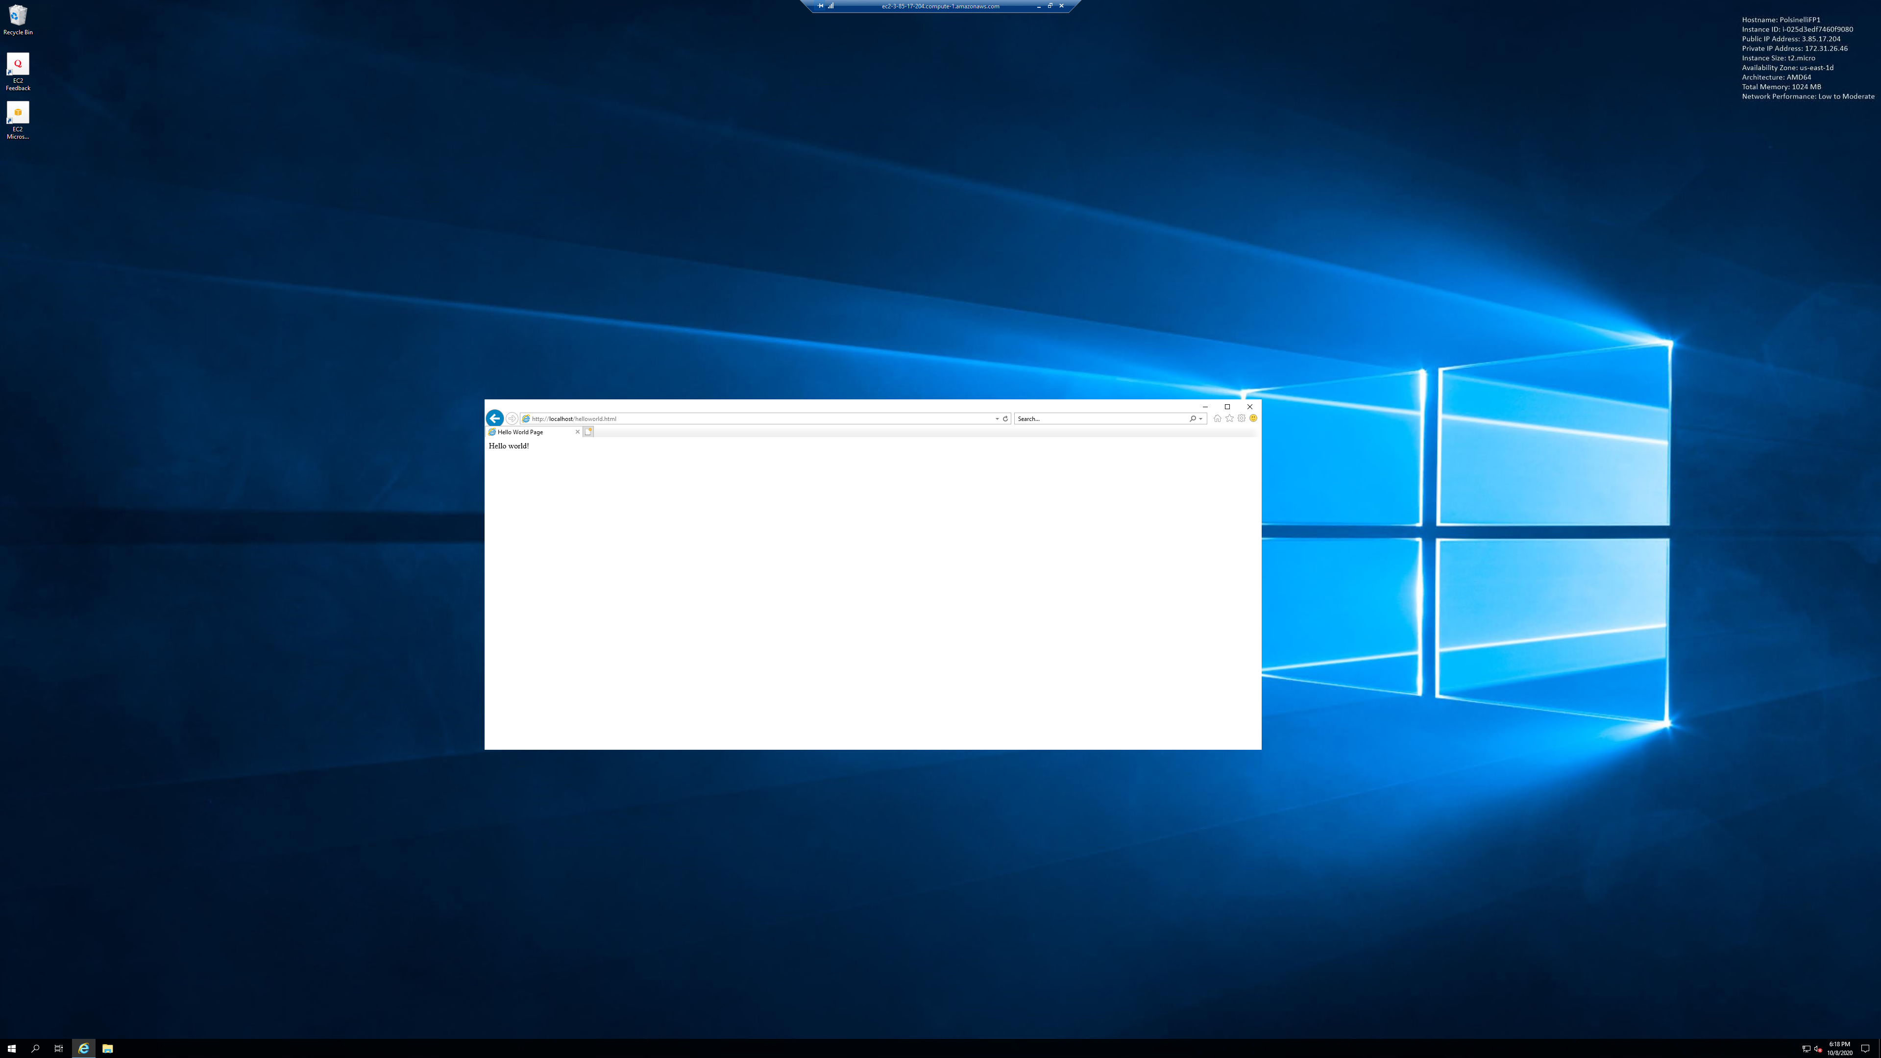

**Figure 5**

*A screenshot of PolsinelliFP2 and localhost.*

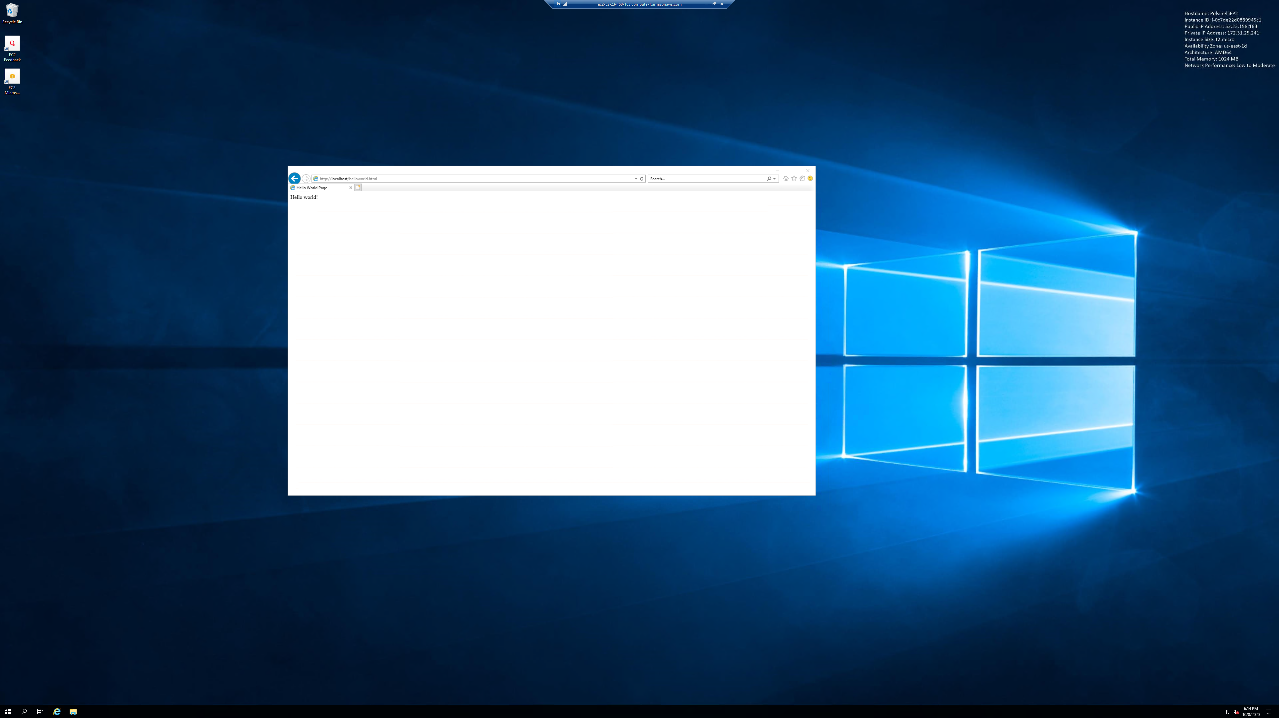

**Figure 6**

*A screenshot of the healthy Targets.*

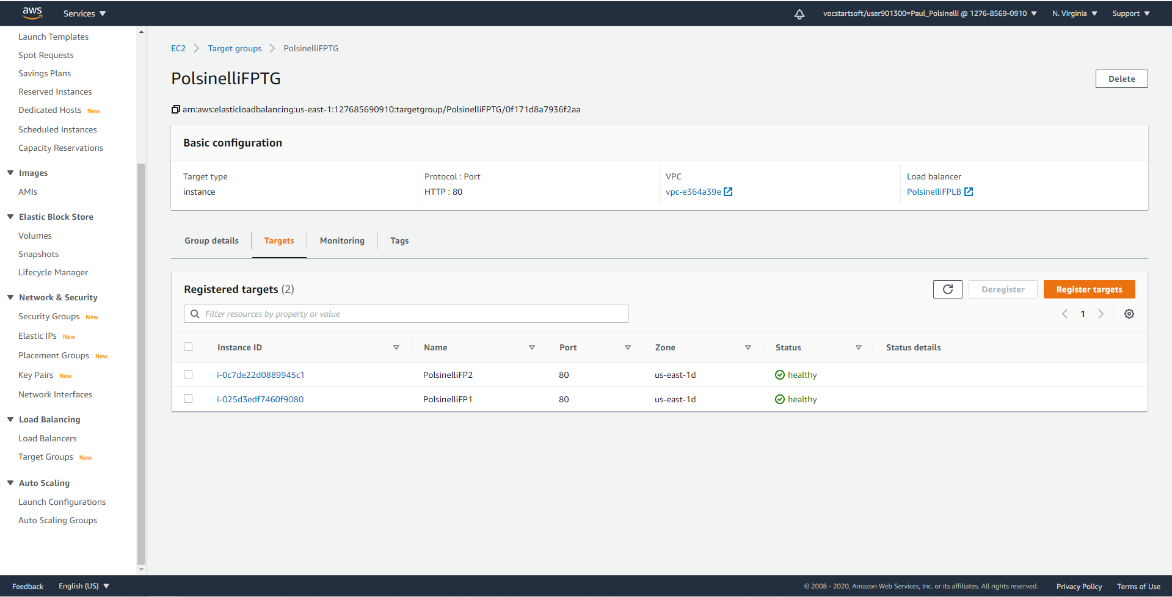

**Figure 7**

*A screenshot of the load balancer with URL.*

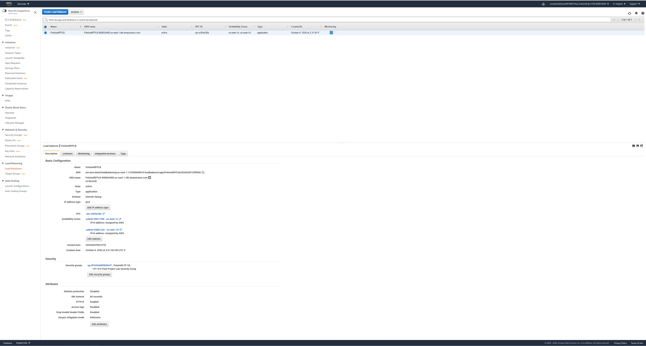

**Figure 8**

*A screenshot showing accessing the webpage using the load balancer URL.*

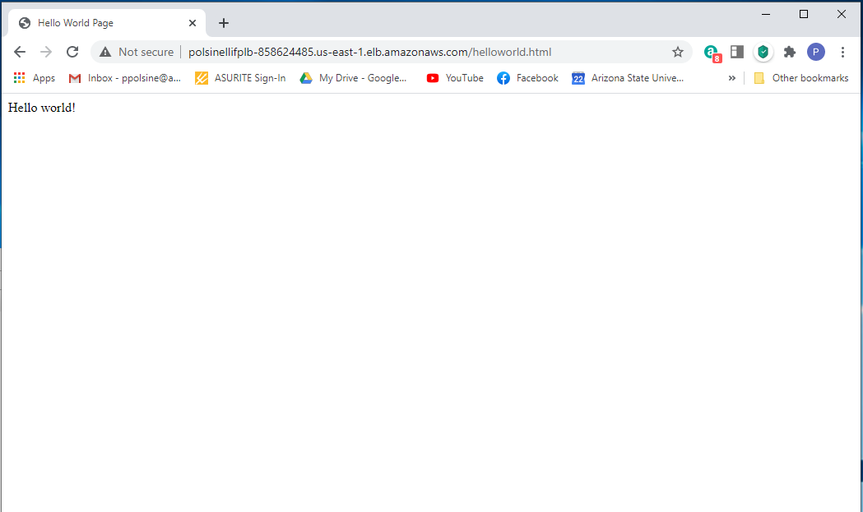

**Figure 9**

*A screenshot of CloudFront with URL.*

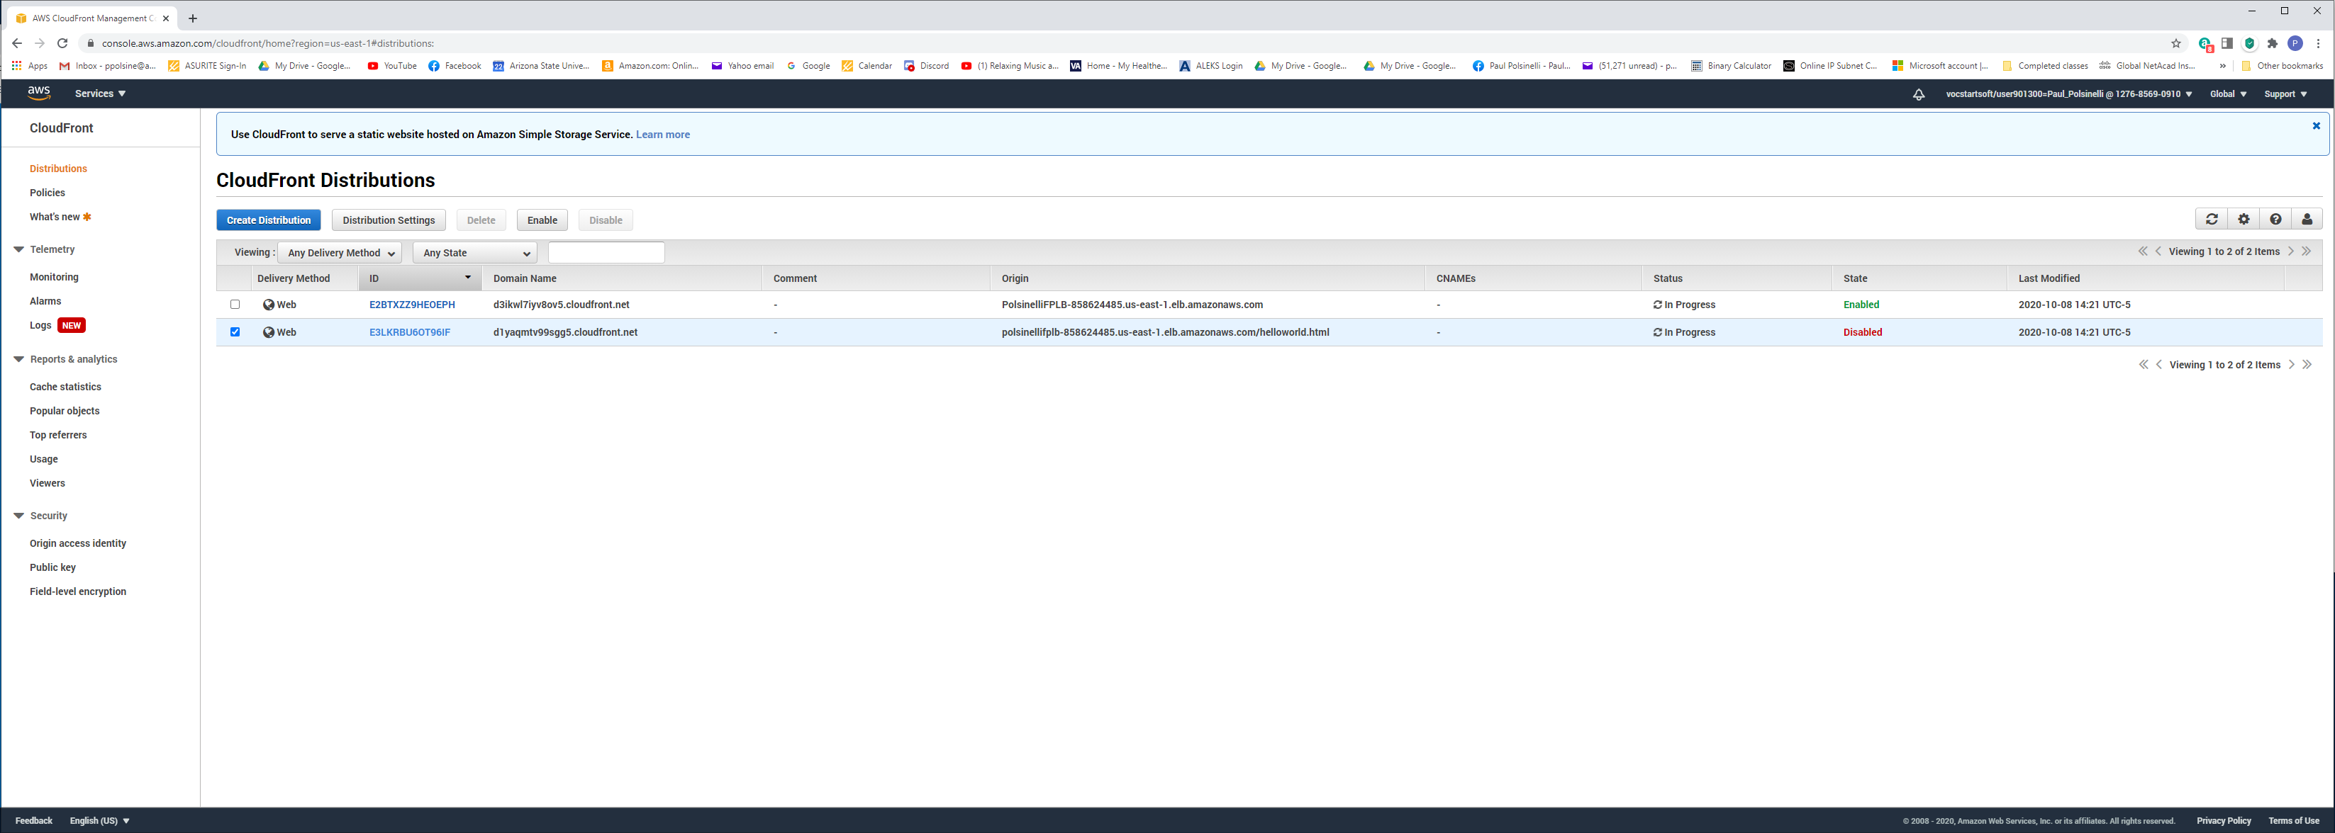

**Figure 10**

*A screenshot showing accessing the webpage using the CloudFront URL.*

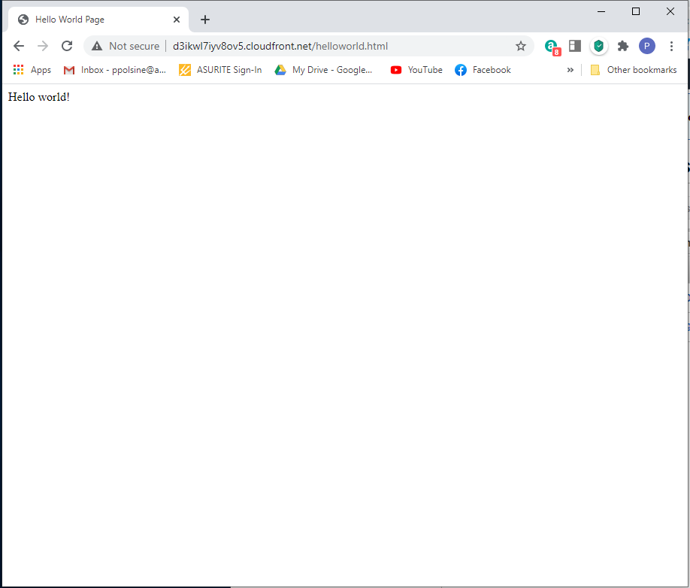

**Figure 11**

*A screenshot showing creation of Route 53 pointing to CloudFront URL.*

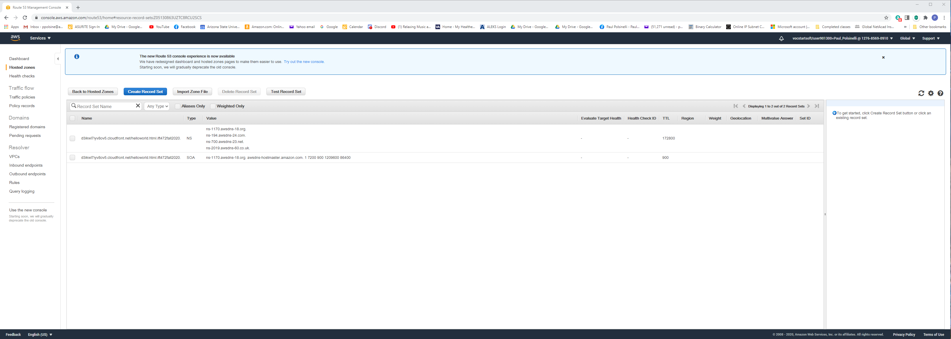

**Figure 12**

*A screenshot of* *CloudWatch metrics showing the resource utilization of both servers.*

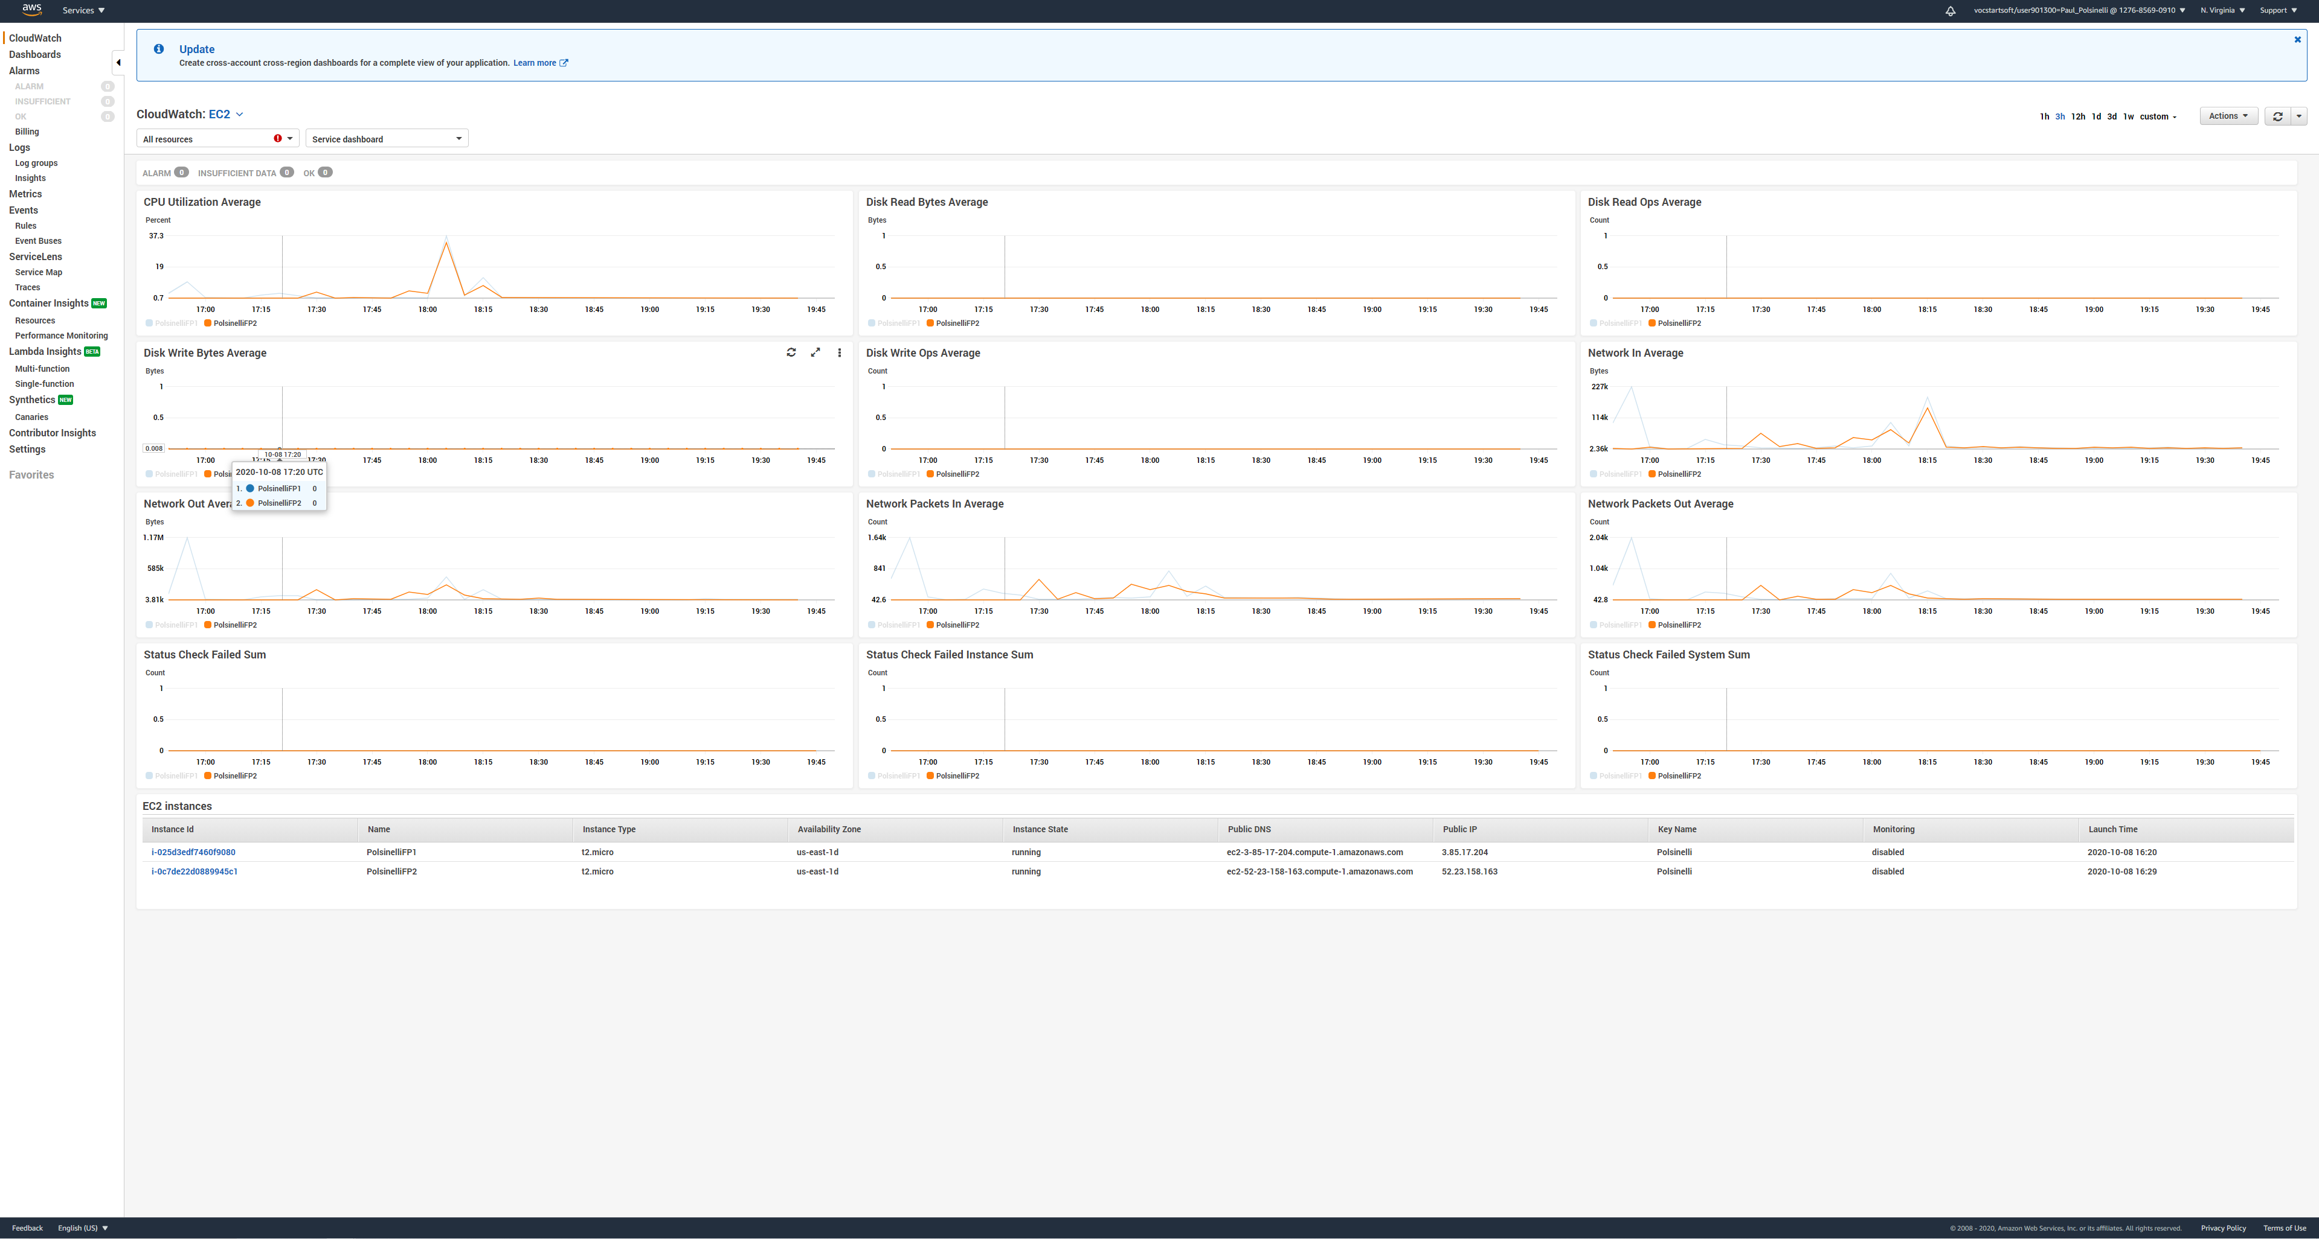

**Figure 12**

*A screenshot of A DynamoDB Table that contains the contact information of ASU., Inc's customers.*

